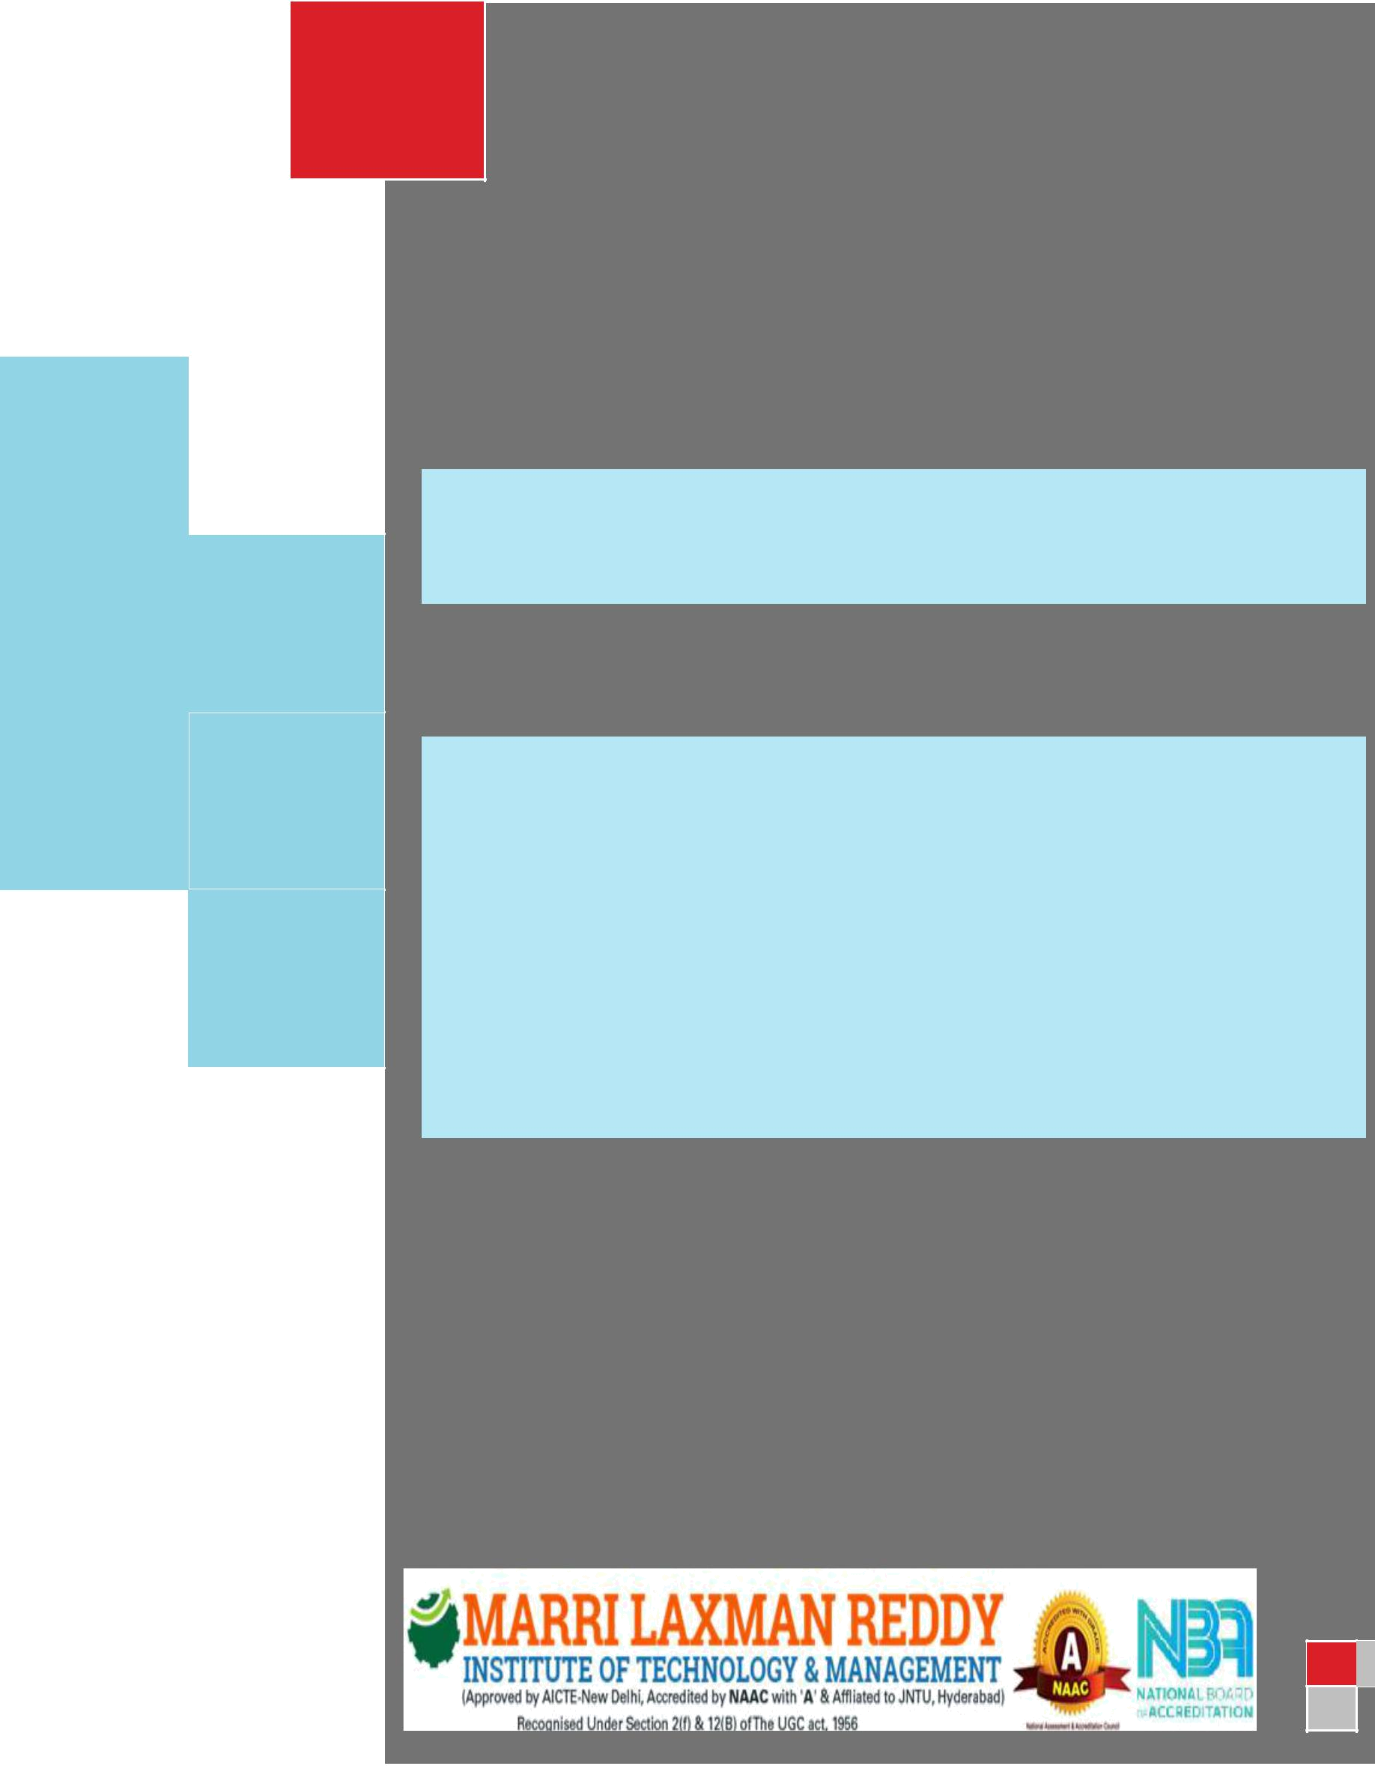
III YEAR
I SEM

Digital

Communication

Lab

DEPARTMENT OF ELECTRONICS AND COMMUNICATION ENGINEERING


CERTIFICATE

This is to certify that this manual is a bonafide record of practical work in the Digital Communications Laboratory in first Semester of third Year B.Tech (ECE) programme during the academic year 2018-19. The manual is prepared by Mrs. P. Sandhya, Asst. Professor and Mr. G. Kiran Kumar, Asst. Professor, Department of ECE.

Signature of HOD Signature of Director Signature of Principal

Department of Electronics & Communications Engineering

III YEAR. B. Tech. ECE- I SEM

LTPC

Regulation: R16

0032

DIGITAL COMMUNICATION LAB
Note:
- Perform any 12 Experiments
- Hardware Testing to be done

List of Experiments:

- PCM Generation and Detection.

- Differential Pulse Code Modulation.

- Delta Modulation.
- Adaptive Delta Modulation.

- Time Division Multiplexing of 2 band limited signals.

- Frequency shift Keying: Generation and Detection.

- Phase Shift Keying: Generation and Detection.

- Amplitude Shift Keying: Generation and Detection.

- Study of the spectral characteristics of PAM.
10. Study of the spectral characteristics of PWM.
- Study of the spectral characteristics of QAM.
- DPSK: Generation and Detection.
- QPSK: Generation and Detection.
- OFDM: Generation and Detection.

LAB I/C LAB FACULTY



INDEX
S. No CONTENT

PREFACE

ACKNOWLEDGEMENT

GENERAL INSTRUCTIONS

SAFETY PRECAUTIONS

INSTITUTE VISION AND MISSION

DEPARTMENT VISION MISSION, PROGRAMME EDUCATIONAL OBJECTIVES

PROGRAMME OUTCOMES

COURSE STRUCTURE, OBJECTIVES & OUTCOMES EXPERIMENTS LEARNING OUTCOMES EXPERIMENTS

 | PCM Generation and Detection. | 1-6
 | Differential Pulse Code Modulation. | 7-12
 | Delta Modulation. | 13-17
 | Adaptive Delta Modulation.  . | 18-23
 | Time Division Multiplexing of 2 band limited signals. | 24-29
 | Frequency shift Keying: Generation and Detection. | 30-34
 | Phase Shift Keying: Generation and Detection.
 | Amplitude Shift Keying: Generation and Detection.
 | Study of the spectral characteristics of PAM.
 | Study of the spectral characteristics of PWM.
 | Study of the spectral characteristics of QAM.
 | DPSK: Generation and Detection.
 | QPSK: Generation and Detection.
 | OFDM: Generation and Detection.

Page No

i

ii

iii

iv

v

vi

vii

viii

x

1-

MLRITM Department of ECE

PREFACE

It is one of the core areas of ECE and constitutes the largest applications in use today. Communication has entered into every part of today’s world. This laboratory is intended to make students understand the use of different Digital Communication Lab is designed to help students understand the basic principles of communication techniques and simulation and hardware implementation of circuits. The main aim is to provide hands‐on experience to the students so that they are able to put theoretical concepts to practice. The content of this course digital communication consists of Hardware design and testing to be done. Students will carry out design of experiments as a part of the experiments list provided in this lab manual. Students will be given a specific design problem, which after completion they will verify using the components and hardwired implementation.

By
Mrs. P. Sandhya,
Mr. G. Kiran Kumar,
Asst. Professor, Department of ECE.

i

MLRITM Department of ECE

ACKNOWLEDGEMENT

It was really a good experience, working at Digital Communications lab. We express our sincere thanks to Mr.K.N.Bhushan, Head of the Department of ECE, Marri Laxman Reddy Institute of technology & Management, for his concern towards us and gave us opportunity to prepare Digital Communication laboratory manual. We are deeply indebted and gratefully acknowledge the constant support and valuable patronage of Dr.R.Kotaih (Director), Marri Laxman Reddy Institute of technology & Management. We are unboundedly grateful to him for timely corrections. We express our hearty thanks to Dr.K.Venkateswara Reddy (Principal), Marri Laxman Reddy Institute of technology & Management, for giving us this wonderful opportunity for preparing the Digital Communications laboratory manual.

At last, but not the least we would like to thank the entire ECE Department faculties those who had inspired and helped us to achieve my goal.

Prepared By
Mrs. P. SANDHYA,
Mr. G. Kiran Kumar,
Asst.Professor, Department of ECE.

ii

MLRITM Department of ECE

GENERAL INSTRUCTIONS

- Students should report to the concerned labs as per the timetable schedule.
- Students who turn up late to the labs will in no case be permitted to perform the experiment scheduled for the day.
- After completion of the experiment, certification of the concerned staff in-charge in the observation book is necessary.
- Students should bring a notebook of about 100 pages and should enter the readings/observations into the notebook while performing the experiment.
- The record of observations along with the detailed experimental procedure of the experiment.
- Performed in the immediate last session should be submitted and certified by the staff member in-charge.
- Not more than one student is permitted to perform the experiment on a setup.
- When the experiment is completed, students should disconnect the setup made by them, and should return all the components/instruments taken for the purpose.
- Any damage of the equipment or burnout of components will be viewed seriously by putting penalty.
- Students should be present in the labs for the total scheduled duration.
- Students are required to prepare thoroughly to perform the experiment before coming to Laboratory.
- Procedure sheets/data sheets provided to the student’s should be maintained neatly and to be returned after the experiment.

iii

MLRITM Department of ECE

SAFETY PRECAUTIONS

- No horseplay or running is allowed in the labs.
- No bare feet or open sandals are permitted.
- Before energizing any equipment, check whether anyone is in a position to be injured by your actions.
- Read the appropriate equipment instruction manual sections or consult with your instructor.
- Before applying power or connecting unfamiliar equipment or instruments into any circuits.
- Position all equipment on benches in a safe and stable manner.
- Do not make circuit connections by hand while circuits are energized. This is especially.
- Dangerous with high voltage and current circuits.

iv

MLRITM Department of ECE

INSTITUTE VISION AND MISSION

VISION

To establish ideal academic institutions in the service of the nation, the world and the humanity by graduating talented engineers to be ethically strong, globally competent by conducting high quality research, developing breakthrough technologies, and disseminating and preserving technical knowledge.

MISSION

To fulfil the promised vision through the following strategic characteristics and aspirations:

- An atmosphere that facilitates personal commitment to the educational success of students in an environment that values diversity and community.
- Prudent and accountable resource management.
- Undergraduate programs that integrate global awareness, communication skills and Leadership and service to meet society’s needs;
- Education and research partnerships with colleges, universities, and industries to graduate education and training that prepares students for interdisciplinary engineering research and advanced problem solving.
- Highly successful alumni who contribute to the profession in the global society.

v

MLRITM Department of ECE

DEPARTMENT VISION, MISSION, PROGRAMME EDUCATIONAL

VISION

Imparting quality technical education through research, innovation and team work for a lasting technology development in the area of Electronics and Communication Engineering.

MISSION

To develop a strong centre of excellence for education and research with excellent infrastructure and well qualified faculties to instil in them a passion for knowledge.

PROGRAM EDUCATIONAL OBJECTIVES

Graduates of the program will

PEO 1: have successful careers in Industry.

PEO 2: show excellence in higher studies/ Research.

PEO 3: show good competency towards Entrepreneurship.

PROGRAM SPECIFIC OUTCOMES

PSO1: Analyze and design Digital circuits or systems for a given specification and function.

PSO2: Implement functional blocks of hardware designs for digital Communication.

vi

MLRITM Department of ECE

Program Outcomes (POs)

PO 1: An ability to apply knowledge of Science, Mathematics, Engineering & Computing fundamentals for the solutions of Complex Engineering problems.

PO 2: An ability to identify, formulates, research literature and analyze complex engineering problems using first principles of mathematics and engineering sciences.

PO 3: An ability to design solutions to complex process or program to meet desired needs

PO 4: Ability to use research-based knowledge and research methods including design of experiments to provide valid conclusions.

PO 5: An ability to use appropriate techniques, skills and tools necessary for computing practice.

PO 6: Ability to apply reasoning informed by the contextual knowledge to assess social issues, consequences & responsibilities relevant to the professional engineering practice.

PO 7: Ability to understand the impact of engineering solutions in a global, economic, environmental, and societal context with sustainability.

PO 8: An understanding of professional, ethical, social issues and responsibilities.

PO 9: An ability to function as an individual, and as a member or leader in diverse teams and in multidisciplinary settings.

PO 10: An ability to communicate effectively on complex engineering activities within the engineering community.

PO 11: Ability to demonstrate and understanding of the engineering and management principles as a member and leader in a team.

PO 12: Ability to engage in independent and lifelong learning in the context of technological change.

vii

MLRITM Department of ECE

COURSE STRUCTURE,OBJECTIVES & OUTCOMES

COURSE STRUCTURE

Level | Credits | Periods/Week | Prerequisites
UG | 2 | 3 | DC

Evaluation Scheme:

MID (Internal Lab) Semester Test | 10 marks
Day to day evaluation | 15 marks
End Semester Lab external Examination | 75 marks

The end semester examination shall be conducted with an external examiner and internal examiner. The external examiner shall be appointed by the principal / Chief Controller of examinations
COURSE OBJECTIVE

At the end the students will be able to:
- Developing and understanding of the design of DIGITAL communication system.
- Study of digital modulation techniques.
- Subject will develop analytical abilities related to Circuit members.

- Establishing a firm foundation for the understanding of telecommunication systems, and the relationship among various technical factors when such systems are designed and operated.

COURSE OUTCOMES:

 | 1. | Understand the significance of digital communication system.
Digital | 2. | Able to design the amplitude shift keying circuit.
Communications Lab |  | To understand and analyze the concepts of Frequency shift keying.
 | 3.
 | 4. | To understand and analyze the concepts of Phase Shift Keying.

viii

MLRITM Department of ECE

DIGITAL COMMUNICATIONS LAB

OBJECTIVES:

This lab aims at

- Developing and understanding the design of Digital communication system.

- Study of digital modulation techniques.

- Establishing a firm foundation for the understanding of telecommunication systems and the relationship among various technical factors when such systems are designed and operated.

- Lab will develop analytical abilities related to circuit members.

OUTCOMES:

Upon completion of the lab, student will be able to

- Able to design the amplitude shift keying circuit and become adept at using the same in real time applications.
- Able to design the frequency shift keying circuit and become adept at using the same real time applications.
- Able to design logic circuits with the help of discrete components and become adept at using the same in real time applications.
- Able to design logic circuits with the help of discrete components and become adept at using the same in real time applications.
- Able to design logic circuits with the help of discrete components and become adept at using the same in real time applications.

ix
MLRITM Department of ECE
EXPERIMENTS LEARNING OUTCOMES

AMPLITUDE SHIFT KEYING
Objective:
To understand and analyze the concepts of amplitude shift keying and its applications.
Outcome:
Able to design the amplitude shift keying circuit and become adept at using the same in real

time applications.

FREQUENCY SHIFT KEYING
Objective:
To understand and analyze the concepts of Frequency shift keying and its applications.
Outcome:
Able to design the frequency shift keying circuit and become adept at using the same in real

time applications.

PHASE SHIFT KEYING
Objective:
To understand and analyze the concepts of Phase Shift Keying and its applications.
Outcome:
Able to design logic circuits with the help of discrete components and become adept at using the same in real time applications.

TIME DIVISION MULTIPLEXING
Objective:
To understand and analyze the concepts of Time Division Multiplexing and its applications.
Outcome:
Able to design logic circuits with the help of discrete components and become adept at using the same in real time applications.

DELTA MODULATION
Objective:
To understand and analyze the concepts of Delta Modulation and its applications.
Outcome:
Able to design logic circuits with the help of discrete components and become adept at using the same in real time applications.

DIFFERENTIAL PHASE SHIFT KEYING
Objective:
To understand and analyze the concepts of Differential Phase shift keying and its applications.
Outcome:
Able to design logic circuits with the help of discrete components and become adept at using the same in real time applications.

1. PCM GENERATION AND DETECTION

AIM:

To study the pulse code modulation and demodulation and to study the effect on the variation of the amplitude of modulating signal.

EQUIPMENT REQUIRED:

- Pulse code modulation and demodulation trainer kit

- Dual trace oscilloscope –20M Hz

- BNC probes

- Patch cards

BLOCK DIAGRAM:
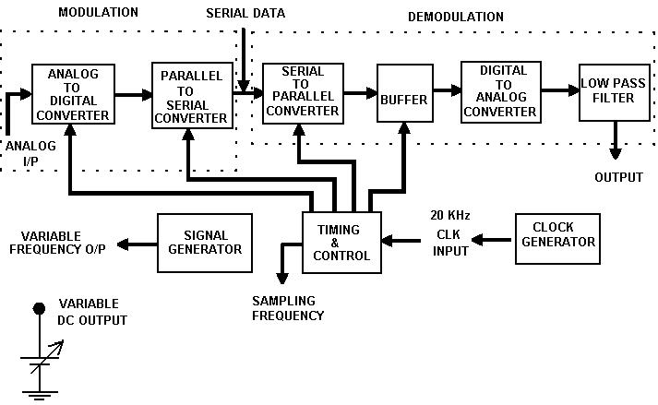

THEORY:

PCM also uses the sampling technique but it differs from the others in that it is a digital process. That is instead of sending a pulse train capable of continuously varying one of the parameters the PCM generator produced a series of numbers of digits each one of the these digits almost always in binary code represents the approximate amplitude of the signal sample at that instant.

In PCM the total amplitude range which the signal may occupy is divided into number of standard levels, the actual number of levels is power 2 by a process called quartering the level actually sent at any sampling time is the nearest standard level. the digit 7 is sent at the instant of time as a series of pulses corresponding to number 7 since there are 16 levels 4 binary places are required the number becomes 0111 and could be sent as OPPP where P= pulse and O no. of pulses. Actually it is often sent as a binary back to front i.e. as 1110 or PPP0 to make demodulation easier.

The signal is continuously sampled quantized coded and sent as each sample amplitude is connected to the nearest standard amplitude and into the corresponding back to front binary number provide soggiest quartering levels are used, the result cannot be distinguished from that of analog transmission.

A signalling bit is generally added to each code group representing a quantized sample. Hence each group of pulsed denoting a sample here called a word is expressed by means of n+ 1 bit whiter 2^{n} is the chosen number of standard levels.

PCM requires very complex encoding quartering circuitry. PCM requires a large bandwidth compared to analog systems the main application of PCM is telegraphy the use of PCM is broadband network of advanced countries is increasing by leaps and bounders PCM also finds use in space communications.

PROCEDURE:

- Connect the circuit as shown in figure.

- Apply varying digital input.

- Calculate decimal number form the applied binary and it will be obtained by

observing LED’s.

- The demodulated output voltage is calculated theoretically by using the formula

v= 5 – (Decimal * 5/128).

- Observe the demodulated output voltage in Multi-meter.

TABULAR FORM:

S.NO. | Applied DC | Binary input | Practical value
 | voltage

MODEL GRAPH:

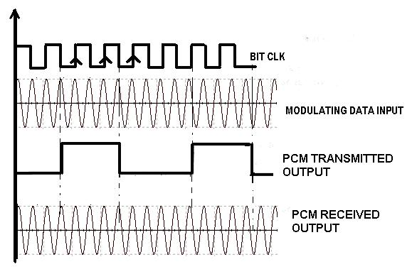

RESULT: Thus the A/D and D/A are converted using PCM modulation and demodulation systems

VIVA QUESTIONS:

- What is the expression for transmission bandwidth in a PCM system?
- What is the expression for signalling rate in a PCM system?
- Explain Sampling Theorem for band limited signals.
- Draw the internal structure of PCM encoder.
- Define quantization in PCM.
- How an ADC works in PCM.
- What are the components of ADC?
- Why ADC requires Parallel to series converter.
- What is band pass sampling?
- What is the expression for quantization noise /error in PCM system?
- What are the applications of PCM?
- Define encoding in PCM.
- Why buffer is placed in PCM generation.
- Compare PCM and DPCM.
- What are the advantages of the PCM?
- What are the disadvantages of PCM?
- Essence of Sampling in PCM.
- Write is the expression for Nyquist rate and Nyquist interval?
- Define the term quantization noise.
- What is quantizing error?
- Construct the generation block diagram of pulse code modulation.
- What is a word in PCM mean?
- What is mean by quantization?
- What is the major effect in PCM?
- What happens to amplitude in PCM?
- How to reconstruct a PCM data.
- Define Sampling in PCM.
- Draw the detection block diagram of pulse code modulation.
- How a Sample and Hold (S/H) will provide Stair case waveform.
- How a DAC works in PCM.
- What are the components of DAC?
- Why DAC requires series to Parallel converter.
- What are the types of sampling?
- Write the statement of Sampling Theorem.
- What is base band sampling?
- Why buffer is placed in PCM detection.
- What are the amplitude levels of a binary PCM?
- Why q-level quantizer is used in PCM.
- What is relation between quantization levels and no of binary digits?
- What is the step size in PCM?
- Difference between PCM and DM.
- Why step size is fixed in PCM.
- Why PCM will have redundant samples.
- What are the encoding methods in PCM?
- Where we use PCM encoders.
- If PCM data contains duplicate samples then what we need to do.
- Draw the internal structure of PCM decoder.
- What is the transmission bandwidth of PCM?
- How PCM signals are used in CODEC systems.
- Why PCM requires high data rates.

Real Time Applications:

- CD laser Discs
- Voice mail
- Digital Telephony
- Compact Disc Audio and Video recording
- Space Communication
- Magnetic tape recoding
- Radio Transmission
- TV broadcasting
- Digital audio processing in computers

2. DIFFERENTIAL PULSE CODE MODULATION

AIM:

To study differential Pulse Code Modulation and Demodulation by sending variable frequency sine wave and variable D.C. signal inputs.

EQUIPMENT REQUIRED:

- Differential Pulse code modulation and demodulation trainer kit

- Dual trace oscilloscope –20M Hz

- BNC probes

- Patch cards

BLOCK DIAGRAM:

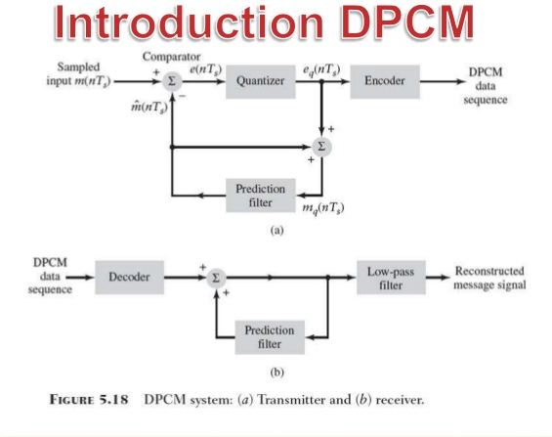

THEORY:

PCM also uses the sampling technique but it differs from the others in that it is a digital process. That is instead of sending a pulse train capable of continuously varying one of the parameters the PCM generator produced a series of numbers of digits each one of the these digits almost always in binary code represents the approximate amplitude of the signal sample at that instant.

In PCM the total amplitude range which the signal may occupy is divided into number of standard levels, the actual number of levels is power 2 by a process called quartering the level actually sent at any sampling time is the nearest standard level. The digit 7 is sent at the instant of time as a series of pulses corresponding to number 7 since there are 16 levels 4 binary places are required the number becomes 0111 and could be sent as OPPP where P= pulse and O no of pulses. Actually it is often sent as a binary back to front i.e. as 1110 or PPP0 to make demodulation easier.

The signal is continuously sampled quantized coded and sent as each sample amplitude is connected to the nearest standard amplitude and into the corresponding back to front binary number provide soggiest quartering levels are used, the result cannot be distinguished from that of analog transmission.

A signalling bit is generally added to each code group representing a quantized sample. Hence each group of pulsed denoting a sample here called a word is expressed by means of n+ 1 bit whiter 2^{n} is the chosen number of standard levels.

PCM requires very complex encoding quartering circuitry. PCM requires a large bandwidth compared to analog systems the main application of PCM is telegraphy the use of PCM is broadband network of advanced countries is increasing by leaps and bounders PCM also finds use in space communications.

PROCEDURE:

- Switch 'ON' the experimental kit.
- Apply the variable D.C. signal to the input terminals of DPCM.
- Observe the sampling output on CRO.
- Observe the output of DPCM on the second channel of CRO.
- By adjusting the D.C. Voltage potentiometer we can get the DPCM output from 0000 0000 to 1111 1111.
- Now, disconnect the D.C. voltage and apply AF oscillator output to the input of the DPCM Modulator.
- Observe the output of conditioning amplifier (Differential output) and DPCM outputs in synchronization with the sampling signal.
- During demodulation, connect DPCM output to the input of the Demodulation and observe the output of DPCM Demodulations.

MODEL GRAPH:

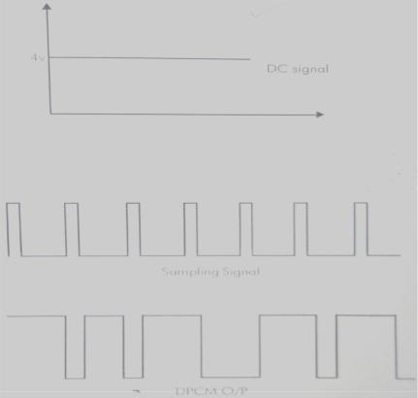

RESULT: Hence observed differential pulse code modulation and demodulation

VIVA QUESTIONS:

- Define Differential PCM.
- How DPCM is generated.
- What is the drawback of PCM?
- Compare DPCM with delta modulation.
- How prediction filter is used to generate next samples in DPCM.
- DPCM is which type of modulation.
- What are the drawbacks of PCM?
- Draw the internal structure of PCM encoder.
- Define quantization in PCM.
- How an ADC works in PCM.
- What are the components of ADC?
- Why ADC requires Parallel to series converter.
- What is band pass sampling?
- What is the expression for quantization noise /error in PCM system?
- What are the applications of PCM?
- Define encoding in PCM.
- Why buffer is placed in PCM generation.
- Compare PCM and DPCM.
- What are the advantages of the PCM?
- What are the disadvantages of PCM?
- Essence of Sampling in PCM.
- Write is the expression for Nyquist rate and Nyquist interval?
- Define the term quantization noise.
- What is quantizing noise?
- Construct the generation block diagram of pulse code modulation.
- What is encoding quartering circuitry?
- What is a word in PCM mean?
- What is mean by quantization?
- What is the major effect in PCM?
- What happens to amplitude in PCM?
- How to reconstruct a PCM data.
- Define Sampling in PCM.
- Draw the detection block diagram of pulse code modulation.
- How a Sample and Hold (S/H) will provide Stair case waveform.
- How a DAC works in PCM.
- What are the components of DAC?
- Why DAC requires series to Parallel converter.
- What are the types of sampling?
- Write the statement of Sampling Theorem.
- What is base band sampling?
- Why buffer is placed in PCM detection.
- What are the amplitude levels of a binary PCM?
- Why q-level quantizer is used in PCM.
- What is relation between quantization levels and no of binary digits?
- What is the step size in PCM?
- Difference between PCM and DM.
- Why step size is fixed in PCM.
- Why PCM will have redundant samples.
- What are the encoding methods in PCM?
- If PCM data contains duplicate samples then what we need to do.

Real Time Applications:

- It is used in lossy compression techniques.

- Coarser Quantization.

- Audio compression method.

- Correlation techniques.

- Compression of mpeg.
- Voice mail
- Digital Telephony
- Compact Disc Audio and Video recording
- Space Communication
- Magnetic tape recording.
3. DELTA MODULATION

AIM:

To study the delta Modulation and Demodulation process

EQUIPMENT REQUIRED:

Delta Modulation and Demodulation Trainer kit.

CRO- 20/25MHz

BNC probes

Patch cards.

BLOCK DIAGRAM:
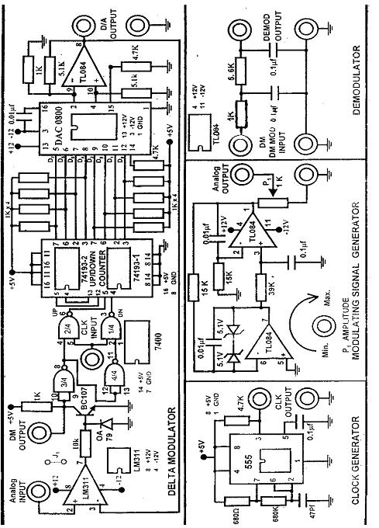

THEORY:

Delta modulation may be viewed, as a simplified form of DPCM is which two level quietuses are used in conjunction with a fixed first order predictor. DPCM is based on the explanation of signal correlation when base band signals are sampled at Nyquist rate correlation between the adjacent samples can be further increased by over sampling the signal at a rate much higher than the Nyquist rate. The higher correlation between the sampler permit. Method to use a simpler quantizing strategy for constructing the encoded signal. The very concept has led to the development of delta modulation is a one bit variation of DPCM. Applying the sampled version if the incoming message signal to a modulator that involves a summer, quantised and an accumulator interconnected can generate delta modulation. The key to effective use of delta modulation is the proper choice of the step sizes and the sampling rate. The parameters must be chosen in such a way that staircase signal is close approximation of tactual analog waveform. Since they signal has given fixed upper frequency, we know that the fastest rate at which it can change however to account for the fastest possible in the signal the step size or sampling frequency must be increased increasing the sampling frequency results in the delta modulated waveforms that require a large bandwidth increasing the step size increases the quantising error.

PROCEDURE:

- Switch ON the experimental board.
- Connect Clock Signal to the Delta Modulator circuit.
- Connect Modulating Signal to the Modulating signal input of the Delta Modulator and observe the same on channel l of a Dual Trace Oscilloscope.
- Observe the Delta Modulator output on channel II of CRO.
- Connect this Delta Modulator output to the demodulator. Also connect the clock signal to the demodulator.
- Observe the Demodulator output with and without RC filter on CRO.

MODEL GRAPHS:
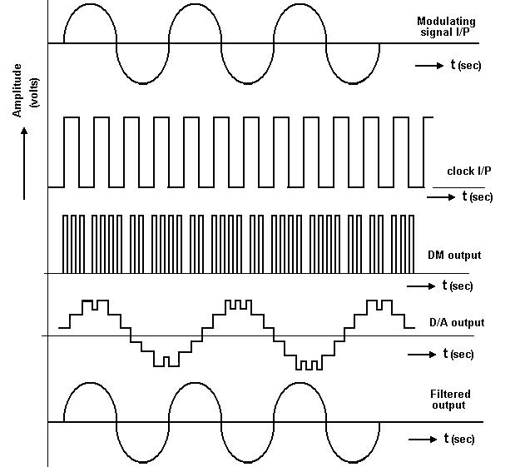

RESULT: Hence studied and observed delta modulation and demodulation

VIVA QUESTIONS:

- Define Delta Modulation.
- Explain the generation process of DM
- What are the drawbacks of DM?
- Compare DM with ADM.
- What is meant by slope over load distortion?
- What is the advantage of DM compare with DPCM?
- Why Delta modulator requires low bit rates.
- What is meant by granular noise distortion?
- Define one bit quantization in DM.
- How an ADC works in PCM and DM.
- What are the components of DM?
- What is band pass sampling?
- What is the expression for quantization noise /error in DM system?
- What are the applications of Delta Modulation?
- Define accumulator in PCM.
- Why delay unit is placed in DM generation.
- Compare DM and DPCM.
- What are the advantages of the DM over PCM?
- What are the disadvantages of DM over PCM?
- Essence of Sampling in DM.
- Write is the expression for Nyquist rate and Nyquist interval?
- Define the term quantization noise.
- What is quantizing error?
- Construct the generation block diagram of delta modulation.
- What is encoding quartering circuitry?
- What is a word in DM means?
- What is mean by 1-bit quantization?
- What is the major effect in PCM on DM?
- What happens to amplitude levels in DM?
- How to reconstruct a DM signal.
- Define Sampling.
- Draw the detection block diagram of Delta modulation.
- How a Sample and Hold (S/H) will provide Stair case waveform.
- How a DAC works in DM.
- What are the components of DAC?
- What are the types of sampling?
- Write the statement of Sampling Theorem.
- What is base band sampling?
- How to compensate Granular in DM.
- Why buffer is placed in DM detection.
- What are the amplitude levels of a DM?
- Why 1-bit quantizer is used in DM.
- What is relation between quantization levels and no of binary digits?
- What is the step size in DM?
- Difference between DM and ADM.
- Why step size is fixed in DM.
- How to compensate Slope over load distortion in DM.
- Why step size must be varied in ADM than DM.
- How delay unit is used to generate predicted values in DM.
- How to reconstruct a DM signal.

Real Time Applications:

- DM is used in Television systems

- PWM signals.

- Conversion of A to D signals

- In high pass filters

- To reduce the noise

4. ADAPTIVE DELTA MODULATION

AIM:

To study the adaptive delta Modulation and Demodulation process.

EQUIPMENT REQUIRED:

Adaptive Delta Modulation and Demodulation Trainer kit.

CRO

BNC probes.

Patch cards.

THEORY:-

The performance of a delta modulator can be improved significantly by making the step size of the modulator assume a time-varying form. In particular, during a steep segment of the input signal the step size is increased. Conversely, when the input signal is varying slowly, the step size is reduced. In this way, the size is adapted to the level of the input signal. The resulting method is called adaptive delta modulation (ADM).There are several types of ADM, depending on the type of scheme used for adjusting the step size. In this ADM, a discrete set of values is provided for the step size. A modem and improved communication system performance that uses multiple modulation scheme comprising modulation technique and encoder combinations. As communication system performance and objective change, different modulation schemes may be selected. Modulation schemes may also be selected upon the communication channel scattering function estimate and the modem estimates the channel scattering function from measurements of the channel's frequency (Doppler) and time (multipath) spreading characteristics. An Adaptive sigma delta modulation and demodulation technique, wherein a quantize step size is adapted based on estimates of an input signal to the quantizer, rather than on estimates of an input signal to the modulator. Digital techniques are used to wirelessly communicate voice information. Wireless environments are inherently noisy, so the voice coding scheme chosen for such an application must be robust in the presence of bit errors. Pulse Coded Modulation (PCM) and its derivatives are commonly used in wireless consumer products for their compromise between voice quality and implementation cost. Adaptive Delta Modulation (ADM) is another voice coding scheme, a mature technique that should be considered for these applications because of its bit error robustness and its low implementation cost.

BLOCK DIAGRAM:

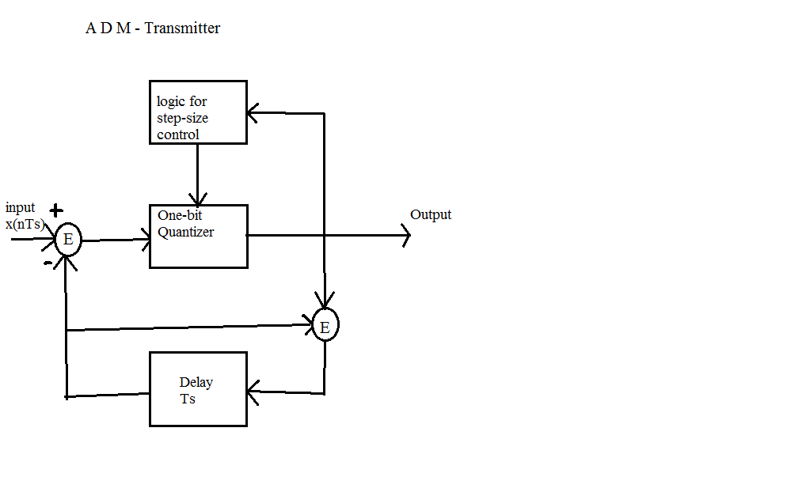

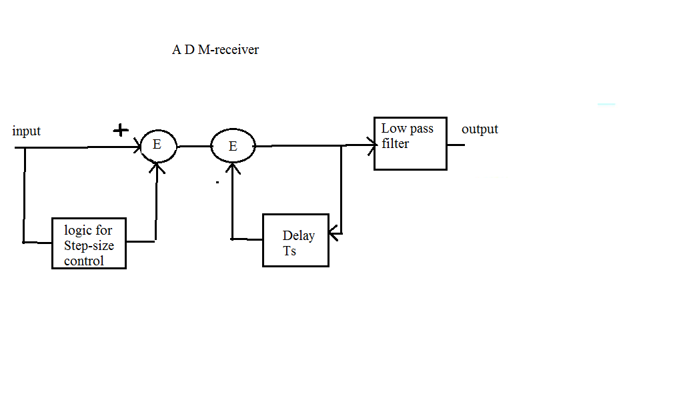

MODEL WAVEFORMS:
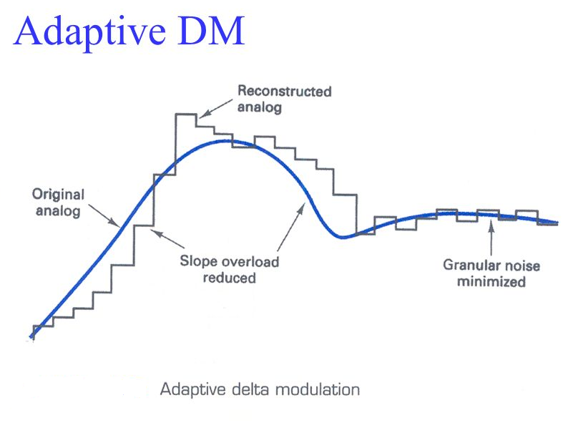

EXPERIMENTAL PROCEDURE:

- Switch on the trainer kit.

- Observe the modulating signal.
- Adjust the modulating signal generator output to convenient value.

- Apply the modulating signal generator output and clock generators output to the ADM modulator.

- Observe the ADM output waveforms by varying the amplitudes of the modulating signal and modulation depths.

PRECAUTIONS:

- Check for loose contacts of wires and components.
- Keep all the control knobs in the minimum position.
- Before switch on the power supply get the circuit connections.
- Adjust the control knobs smoothly.
- After taking the readings bring back all the control knobs to minimum position.
- Switch off the power supply before leaving the experimental table.

Observations:

Amplitude of the modulating signal_______________

- Frequency of the modulating signal_________________

- Amplitude of the De-modulating signal______________

- Frequency of the De-modulating signal_______________

- Sampling frequency___________________

CONCLUSION:

The Adaptive Delta modulation is studied and verified and the output waveforms have been plotted.

VIVA QUESTIONS:
- Define Adaptive Delta Modulation.
- Explain the generation process of ADM
- What are the drawbacks of DM over ADM?
- What are the advantages of ADM?
- Compare ADM with DM.
- What is meant by slope over load distortion.
- What is the advantage of ADM compare with DPCM.
- Why Adaptive Delta modulator requires low bit rates.
- What is meant by granular noise distortion?
- Define one bit quantization.
- How an ADC works in PCM and DM and ADM.
- What are the components of ADM?
- What is band pass sampling?
- What is the expression for quantization noise /error in ADM system?
- What are the applications of Delta Modulation?
- Define accumulator in ADM.
- Why delay unit is placed in ADM generation.
- Compare ADM and DM.
- What are the advantages of the ADM over DM?
- What are the disadvantages of DM over ADM?
- Essence of Sampling in ADM.
- Write is the expression for Nyquist rate and Nyquist interval?
- Define the term quantization noise.
- What is quantizing error?
- Construct the generation block diagram of delta modulation.
- What is encoding quartering circuitry?
- What is a word in ADM means?
- What is mean by 1-bit quantization?
- What is the major effect in DM on ADM?
- What happens to amplitude levels in ADM?
- How to reconstruct a ADM signal.
- Define Sampling.
- Draw the detection block diagram of Delta modulation.
- How a Sample and Hold (S/H) will provide Stair case waveform.
- How a DAC works in ADM.
- What are the components of DAC?
- What are the types of sampling?
- Write the statement of Sampling Theorem.
- What is base band sampling?
- How to compensate Granular in ADM.
- Why buffer is placed in ADM detection.
- What are the amplitude levels of a ADM?
- Why 1-bit quantizer is used in ADM.
- What is relation between quantization levels and no of binary digits?
- What is the step size in ADM?
- Difference between DM and ADM.
- Why step size is fixed in ADM.
- How to compensate Slope over load distortion in ADM.
- Why step size must be varied in ADM than DM.
- How delay unit is used to generate predicted values in ADM.

Real Time Applications:

- Multi threaded processor computer.
- Telephone and radio communications.
- DM is used in Television systems
- PWM signals.
- Conversion of A to D signals
- In high pass filters
- To reduce the noise

5. TIME DIVISION MULTIPLEXING OF 2 BAND LIMITED SIGNALS

AIM:
To study the time division multiplexing by applying different band limited signals to time division multiplexer. Apply the multiplexed output to Demultiplexer and observe the individual signals.

EQUIPMENT REQUIRED: -

TDM Multiplexer and De-multiplexer kit

CRO-20/25MHz

BNC probes

Patch cards.

BLOCK DIAGRAM:
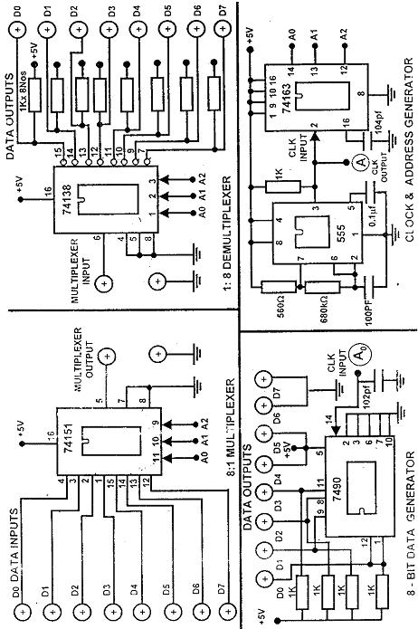

THEORY: -

A time division multiplexing system enables the joint utilization of a common communication channel by a plurality of independent message sources without mutual interference among them. Each input signal is first restricted in bandwidth by a low pass anti aliening filter to remove the frequencies that are non-essential to an adequate signal representation. The low pass filter outputs are then applied to commentator, which is usually implanted using electronic switching circuitry the function of the commutator is twofold. To take a narrow sample of each of the N input messages at rate fs that are slightly higher than 2w where W is the cut-off frequency of the anti-aliening. To sequentially interleave there N samples inside the sampling interval TS In deed this later function is the essence of the time division multiplexing operation following the communication process the multiplied signal is applied to pulse modulator, the purpose of which is to transform the multiplied signal into a form suitable for transmission over the communication channel it is clear that the use of time division multiplying introduces a band width expansion factor N because the scheme must squeeze N samples derived from N independent message sources into a time slot equal to one sampling interval at the receiving end of the system, the receive signal is applied to pulse demodulator, which performs the reverse operation of the pulse modulator. The narrow samples produced at the pulse demodulator output are distributed to the appropriate low pass reconstruction filter by means of a dissimulators which operates in synchronism with the commutator in the transmitter the is synchronization is essential for a satisfactory operation of the system. The way this synchronization is implemented depends naturally on the method of pulse modulation use to transmit the multiplied sequence of samples. The TDM systems are highly sensitive to dispersion in the common channel .so accurate equalization of both magnitude3 and phase response of the channel is necessary to ensure a satisfactory operation of the system.

PROCEDURE:

- Switch on Time Division Multiplexing and De Multiplexing Trainer.

- Connect the sine wave to channel-1, square wave to channel -2 and triangle wave to channel-3 terminals of 8 to 1 Multiplexer.

- Observe the multiplexer output on channel -1 of a CRO.

  - Connect mux output to de-mux input.

  - Observe corresponding signal outputs at channel-2 of CRO.

MODEL GRAPH: -

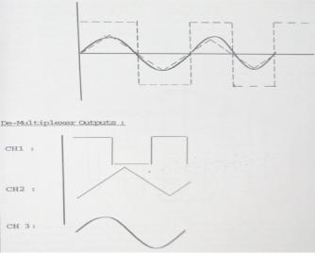

RESULT:

The operation of TDM is observed and the output waveforms are verified.
VIVA QUESTIONS:

- What is the working principle of TDM?
- What is the purpose of commutator in TDM?
- In TDM how does the synchronization can be achieved?
- What are the applications of TDM?
- What is aperture effect?
- What is the working principle of TDM?
- What is the purpose of commutator in TDM?
- In TDM how does the synchronization can be achieved?
- What are the applications of TDM?
- What is aperture effect?
- Why communication is concerned with electronic equipment?
- What are the typical channels used in wire/line communication?
- What is multiplexing?
- What are the types of multiplexing?
- What are the applications of multiplexing?
- Why we need multiplexing?
- What are the advantages of multiplexing?
- What is the disadvantage of multiplexing?
- What are the advantages over modulation techniques?
- Give the expression for modulation index (µ)?
- Which is non orthogonal multiplexing?
- Distinguish between the two basic multiplexing techniques?
- Why sync pulse is required in TDM?
- In what situation multiplexing is used?
- What is difference between Frequency Division multiplexing and Wave Division multiplexing.
- What is the function of an enable input on a multiplexer chip?
- Will multiplexing create additional harmonics in the system?
- Can I accidentally switch a dimmer to multiplex mode?
- Why COSTAS LOOP is used?
- What is the working principle of TDM?
- What is the purpose of commutator in TDM?
- Define TDM.
- Which principle is used in TDM
- Compare TDM with FDM
- In which area TDM is applicable
- Explain the generation of TDM
- Compare PAM & TDM
- What is the function of commentator
- What is the function of De commentator
- Give the application of TDM.
- Why we need multiplexing?
- What are the advantages of multiplexing?
- What is the disadvantage of multiplexing?
- What are the advantages over modulation techniques?
- Which is non orthogonal multiplexing?
- How to multiplex digital data
- How cloud you multiplex video, audio and image at a time.
- Distinguish between the two basic multiplexing techniques?
- Why sync pulse is required in TDM?
- Mention the differences between TDM and FDM.

Real Time Applications:

- In Half duplex communication system

- In Communication systems

- Wireless communication system

- Television system

- Radio Telemetry

- Communication System – A Multiplexer is used in communication systems, which has a transmission system and also a communication network. A Multiplexer is used to increase the efficiency of the communication system by allowing the transmission of data such as audio & video data from different channels via cables and single lines.
- Computer Memory – A Multiplexer is used in computer memory to keep up a vast amount of memory in the computers, and also to decrease the number of copper lines necessary to connect the memory to other parts of the computer.
- Telephone Network – A multiplexer is used in telephone networks to integrate the multiple audio signals on a single line of transmission.
- Transmission from the Computer System of a Satellite: A Multiplexer is used to transmit the data signals from the computer system of a satellite to the ground system by using a GSM communication.

6. FREQUENCY SHIFT KEYING GENERATION & DETECTION
AIM: To generate FSK modulation and demodulation signals.

EQUIPMENT REQUIRED:

FSK modulation and demodulation kit

CRO-20/25MHz

BNC probes

Patch cards.

THEORY:

In FSK systems two sinusoidal carrier waves of same amplitude AC but different frequencies fC1 and fC2 are used to re present binary symbols 1 and 0 respectively. I.e., S(t)=Ac*Cos(2ПfC1,t) symbol1=Ac*Cos(2ПfC2,t) symbol 2 The FSK is essentially a superposition of two ASK waveforms one with frequency fC1 and the other with fC2. Hence the PSD of FSK is the sums of two ASK spectrums at frequencies fC1 and fC2. The bandwidths of FSK are higher than that of PSK and ASK .The application of FSK signals is in low speed digital data transmission.

Generation of FSK:
The FSK signal can be generated by applying the incoming binary data to a frequency modulator and to other input a sinusoidal carrier wave of amplitude AC and frequency fC is applied. As the binary data changes form one level to another (but non zero being pear) the output changes its frequencies is the corresponding manner.

Detection of FSK: -
FSK can be demodulated using synchronous or coherent detector. This type of detection or digital communication reception is also known as correlation reception. The coherent detection requires phase and time synchronization.

BLOCK DIAGRAM:

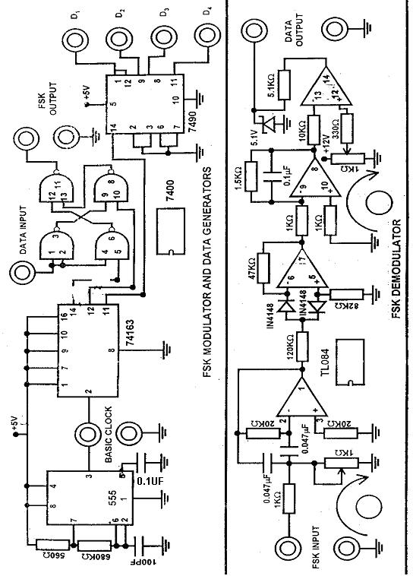

PROCEDURE:

- Switch 'ON' the power to the Trainer.
- Observe the clock frequency on the oscilloscope.
- Apply the clock to the decade counter (7490). And vary the data outputs and draw the data outs.
- Select one data output of the decade counter to the data input point of the FSK modulator and observe the same signal one channel of a dual trace oscilloscope.
- Observe the output of the FSK modulator on the second channel of the CRO.

MODEL GRAPHS:

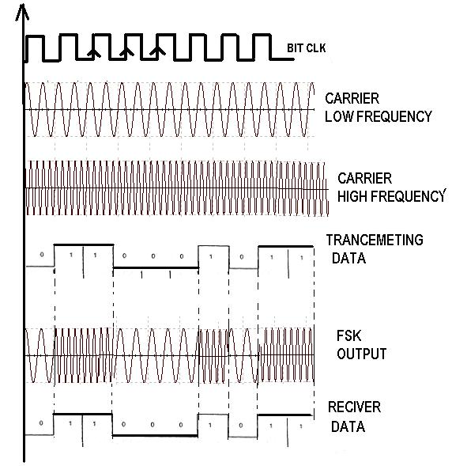

RESULT: -Hence generated frequency modulated and demodulated signals

VIVA QUESTIONS:

- Define Binary FSK signal?
- What is meant by carrier swing?
- What is bandwidth of FSK signal?
- Draw the Spectrum of FSK signal.
- What are the digital modulation techniques?
- Define Frequency deviation of FSK signal?
- What are the advantages of this FSK signal?
- Compare BFSK and BPSK?
- Give the differences between FSK & FM?
- Define Baseband transmission.
- Define Pass band digital transmission.
- What are the requirements of Digital Modulation Techniques?
- What are the advantages of Digital Modulation Techniques?
- What are the drawbacks of Digital Modulation Techniques?
- Draw the waveforms for FSK signal for bipolar NRZ data.
- Compare BFSK and ASK?
- Why we use two carriers in FSK transmission and reception.
- Define coherent detection.
- Define non-coherent detection.
- Compare all the digital modulation techniques?
- What is the probability of error of FSK signal?
- What is meant by frequency synthesizer?
- Applications of frequency synthesizer.
- What is meant by PLL?
- Applications of PLL.
- Define BER rate?
- Write the expression for FSK signal for binary ‘1’?
- Write the expression for FSK signal for binary ‘0’?
- What is the major advantage of coherent FSK over coherent PSK?
- Compare BFSK and QPSK?
- Draw the block diagram of FSK signal detection using coherent detection.
- Draw the block diagram of FSK signal detection using non-coherent detection.
- Draw the block diagram of FSK signal detection using PLL.
- Write the expression for bit error rate for coherent binary FSK.
- What is correlator?
- Compare ASK, PSK and FSK based on their power?
- Compare ASK, PSK and FSK based on their SNR?
- Compare ASK, PSK and FSK based on their probability of error?
- Define modulation rate.
- What BER rate of FSK signal.
- Define coherent detection.
- Define non-coherent detection.
- Compare all the digital modulation techniques?
- What is the probability of error of FSK signal?
- What is the major advantage of coherent FSK over coherent ASK?
- What are the three broad types of synchronization?
- What is carrier synchronization?
- Compare ASK, PSK and FSK based on their bandwidth?
- Draw the time domain waveforms of FSK signal.
- What is expression for FSK signal?

Real Time Applications:

- Amateur radio
- Caller ID
- Emergency broadcasting
- Finance business
- General purpose PLL applications.
- Bluetooth or BLE(Bluetooth Low Energy) which normally used everywhere like in mobile phone, wireless speakers, Laptops, etc uses GFSK( Gaussian Frequency Shift Keying ) modulation technique for data transmission. Difference between GFSK and FSK is nothing but GFSK has an additional Gaussian Filter to reduce the side band power.

